COS 420 - Team B
Deliverable 3 - (3/28/2026)
Busy Bee Calendar - Domain Model

Domain Model Description
The Busy Bee Calendar application helps users organize tasks and events based on priority and scheduling. The central entity is the User, who creates and manages Events. Events are categorized by priority and displayed in a calendar or list view. The system supports creating, editing, deleting, and importing events, as well as submitting support requests.

Domain Model Diagram
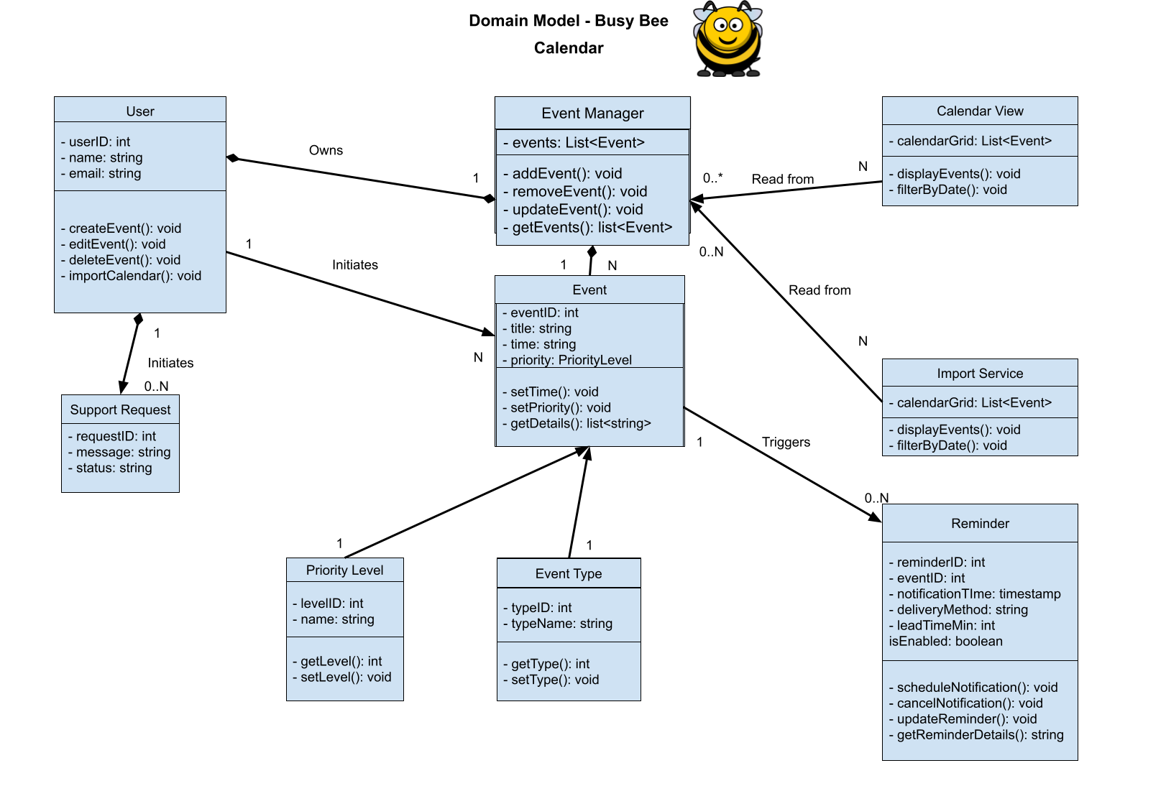

Classes

User
userID: int
name: string
email: string
createEvent(): void
editEvent(): void
deleteEvent(): void
importCalendar(): void

Event Manager
events: List<Event>
addEvent(): void
removeEvent(): void
updateEvent(): void
getEvents(): list<Event>

Calendar View
calendarGrid: List<Event>
displayEvents(): void
filterByDate(): void

Event
eventID: int
title: string
time: string
priority: PriorityLevel
setTime(): void
setPriority(): void
getDetails(): list<string>

Import Service
calendarGrid: List<Event>
displayEvents(): void
filterByDate(): void

Support Request
requestID: int
message: string
status: string
submitRequest(): void
updateStatus(): void

Priority Level
levelID: int
name: string
getLevel(): int
setLevel(): void

Event Type
typeID: int
typeName: string
getType(): int
setType(): void

Reminder
reminderID: int
eventID: int
reminderTime: string
notificationMethod: string
isEnabled: boolean
setReminder(): void
cancelReminder(): void
getReminderDetails(): string

